Measuring the Distance People in Need Travel to Food Pantries

Data Crunch for Social good

Rita Bennett-Chew, Sarah Gauby, SHARIQ IQBAL, Erica Levine, Bharathkumar Ramachandra, Suzy Stiegelmeyer

2015

# Executive Summary

Tasked with exploring the data surrounding the issue of child hunger in North Carolina, we decided to analyze the distance of the food pantries from the people in need. For the purpose of this analysis, we focused on Durham, Johnston, Orange, and Wake Counties in North Carolina. On a census tract level, we gathered information from the American Community Survey about the population: the total number of households, the percentage of households receiving food stamps, the percentage of households with children under 18 years, the percentage of households with children under 18 years receiving foods stamps, and other such categories. In addition, we had received data regarding the food pantries that claimed to serve the four counties on which we were focusing. Combining these two sets of information, we proceeded by calculating the distance from the center of each of these census tracts to the individual food pantries.

Next, we graphed the proportion of households receiving food stamps over the total number of households and the distance from the food pantry. Similarly, we graphed the total number of households receiving food stamps and the distance from the food pantry. In general, we observed that the areas that had more households receiving food stamps were closer to food pantries. However, two anomalies were identified: 413 Johnston County and 112.03 Orange County. These two census tracts showed a large number of households receiving food stamps as well as a longer distance to travel to food pantries.

## Recommendations

We would recommend (1) investigating further the two counties that were identified as having a large number of households receiving food stamps but not much access to food pantries, and (2) …

# Methodology

We received data that contained those food pantries that claimed to serve people in Durham, Johnston, Orange, and Wake Counties in North Carolina. From the American Community Survey (ACS) and census.gov, we found information regarding several different indicators of hunger such as the total number of households, the percentage of households receiving food stamps, the percentage of households with children under 18 years, the percentage of households with children under 18 years receiving foods stamps, and other such. We also found information on other indicators such as those receiving SNAP and WICK; however, due to time constraints we focused on those households receiving food stamps.

After receiving this information, we decided to make a graph of these four counties in order to make a heat map that would help identify those census tracts that were both farther and higher in population of people receiving food stamps. We began by (1) merging the shapefile of NC census tracts with census tracts from ACS based on GEO ID to get another shapefile. This new shapefile only encompassed the four counties in which we were interested. Then we converted this shapefile into a data frame in order to then (2) convert the GEO ID’s into longitudes and latitudes that could be plotted on a map. Next we calculated the distance of the people in need to the food pantries. Due to privacy issues, we cannot know the actual locations of the households in need. Therefore, we used the centroid of the census tract as a central location of these populations. The ACS data contained the longitude and latitude of the centroid point of each of the census tracts. We calculated the Euclidean distance from each centroid point to all of the food pantries. Then we (3) found the minimum distance, which is the distance we graphed and compared.

We began by making a scatter plot of the minimum distance of centroid of the census tract to a food pantry versus the proportion of households receiving food stamps. Next, we made two heat maps: one that graphed the proportion of households that received food stamps and their distance from food pantries and one that graphed the number of households that received food stamps and their distance from food pantries. The locations of the food pantries are also plotted on these two graphs in order to visually demonstrate their distances form the household in need. We included both of these graphs in order to have the both the normalized need (the proportion of households receiving food stamps) as well as the given need (the number of households receiving food stamps).

# Results

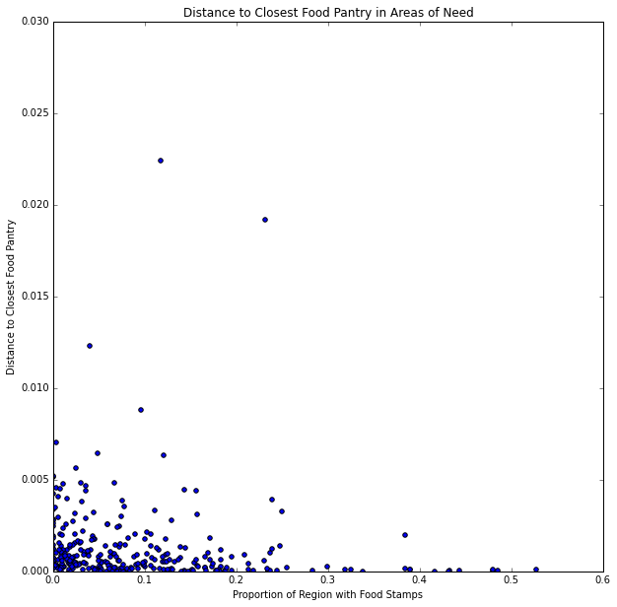

Figure 1: This graph shows the distance from the center of the census tract to the closest food pantry compared to the proportion of households receiving the food stamps. It is helpful in identifying those two counties that should be investigated for lack of food options

This graph shows the general trends we would expect: a somewhat negative trend of the data so the smaller proportions

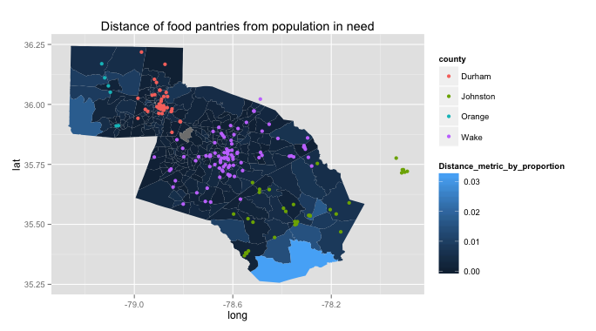Figure 2: This graph shows a heat map of the distance metric on a census tract level. The distance metric multiplies the proportion of households receiving food stamps by the minimum distance from the centroid of the census tract to the closest food pantry. The lighter the color the larger the distance metric, meaning that both the proportion of households receiving food stamps and the distance to food pantries are large. These are the census tracts that you should investigate further.

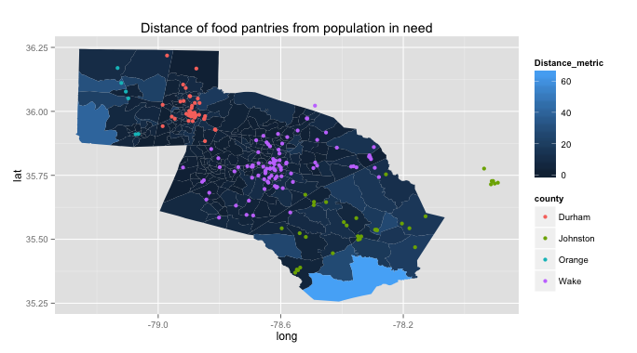

Figure 3: This graph shows a heat map of the distance metric on a census tract level. The distance metric multiplies the proportion of households receiving food stamps by the minimum distance from the centroid of the census tract to the closest food pantry. The lighter the color the larger the distance metric, meaning that both the proportion of households receiving food stamps and the distance to food pantries are large. These are the census tracts that you should investigate further.

# Conclusion